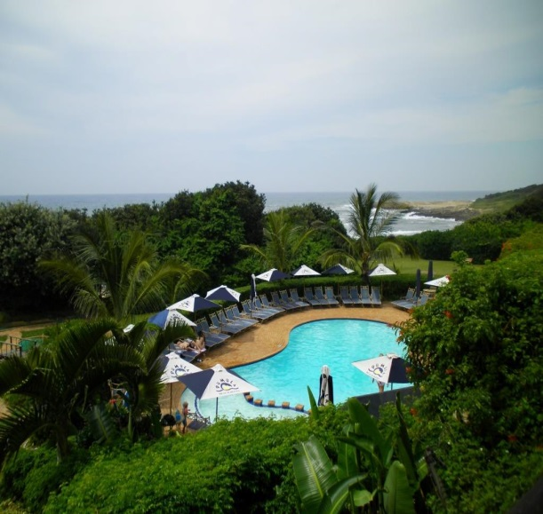
Quantum Information, Processing, Communication and Control ^ 2
25th – 29th November 2013
PUMULA BEACH HOTEL – KWAZULU-NATAL
SOUTH AFRICA
REGISTRATION FEES
HOTEL RESERVATION FORM
Please complete and return this form as soon as possible to:
Lliane Bratherton
Venues for Conferences in Africa
Tel: +27 31 764 0059
e-mail: lliane@venues.co.za

Family Name: …………………………………………………. Initials: …………..…
University / Organisation: …………………………………………………………..….
Mailing Address: ……………………..……………………………………………..…
……………………..……………………………………………..………………………
Country: ………………………………..……………………………………………..…
Telephone: ………………………...……… Fax: ……………………………………
E-mail: ……………………………………..

We wish to reserve accommodation at Pumula Beach Hotel (fully inclusive package per person per day)

Fully inclusive rate:
R1 295.00 per person per day (single)
R1 045.00 per person per day (sharing)

Please would you advise if you will be accompanied by your partner and let us have
their name/s

……………………………………………………………………………………………………

The Conference commence on Monday 25th November 2013 and the suggested departure day is Saturday 30th November 2013 (departure day).

Date of arrival: ……………………………………………………………….……………….

Date of departure: ……………….…………………………………….……………………..

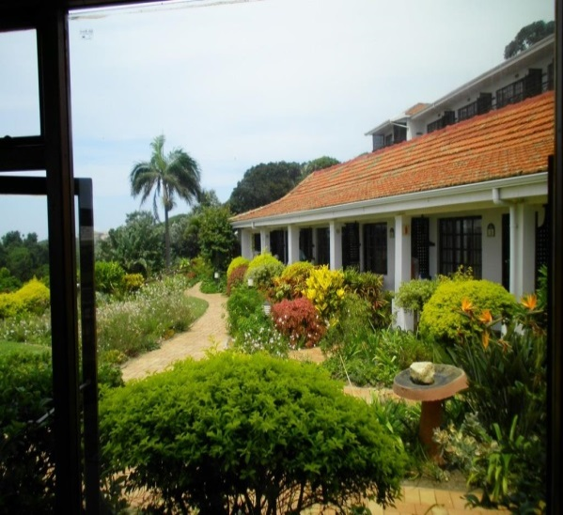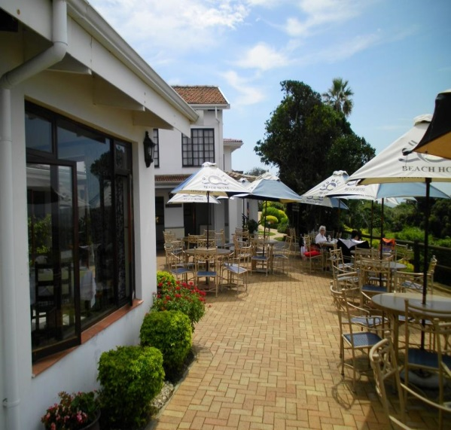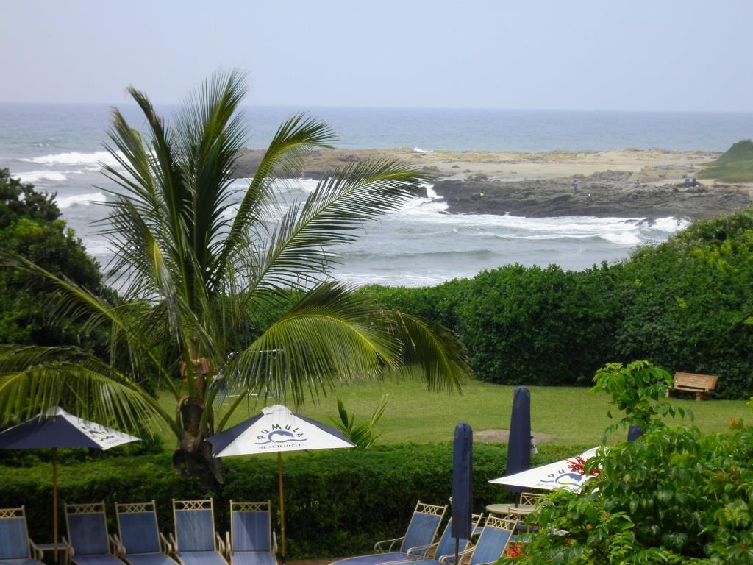
Dietary Requirements:

Vegetarian |  | Halaal |  | Kosher |  | None |  | Other

Other Information e.g. medical conditions:

……………………………………………………………………………………………………
……………………………………………………………………………………………………

Should you wish to arrive earlier or leave later to participate in locally available tours and excursions please advise Vicki Hooper accordingly. vicki@venues.co.za –
083 256 8120. Please see list of available tours and excursions attached.

If you need assistance with flights, please complete the following with your flight requirements:
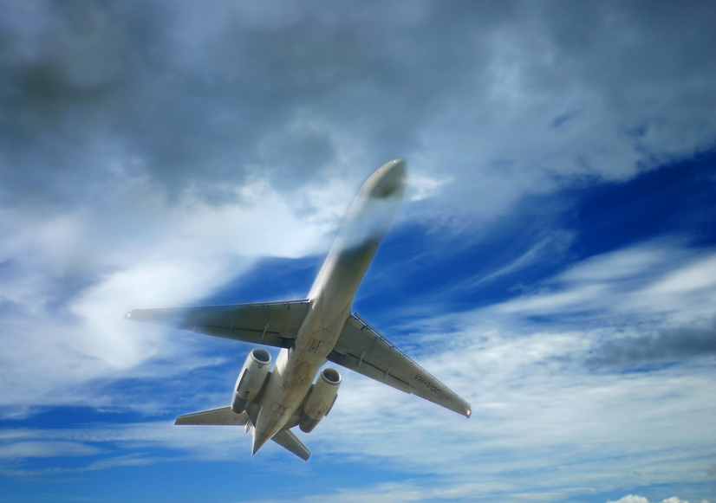 Departure, Destination, date: ……………………………….…………………………..……..

Departure, Destination, date: ……………………………….…………………………..……..

I wish to book return transport to the Hotel from King Shaka International Airport, Durban, South Africa
Shuttle Prices:
1 pax R 1270 per person one way (individual shuttles can be arranged)
2-4 pax R 635 per person one way
7-10 pax R 560 per person one way …………..
Please specify: ………………………………………………………………………………..
(We will advise on shuttle times once you let us know your flight schedule)

The registration fees are R750 per delegate. Total payment due:
Registration Fees | R750
Accommodation
Transport (the cost of transport will be dependent on the number of delegates making a request for this)
TOTAL AMOUNT

Terms & Conditions:
- No walk-ins will be allowed on the day;
- You must ensure that the registration forms are completed in full;
- Once your registration form is received by the organizers confirmation of the reservation will be sent as soon as possible by e-mail together with the instructions for the payment and invoice. The bank account details into which payment should be made will be specified;
- If you have submitted a registration form and you have not received a confirmation number within 48 hours, please contact the organizers to ensure your form has been received.

Date: …………………………….. Signature: ……………………………

